Analysis of I/O Performance Benchmarks

Our benchmarking experiments revealed several interesting patterns in storage device performance, though with notable sources of variance that warrant discussion.

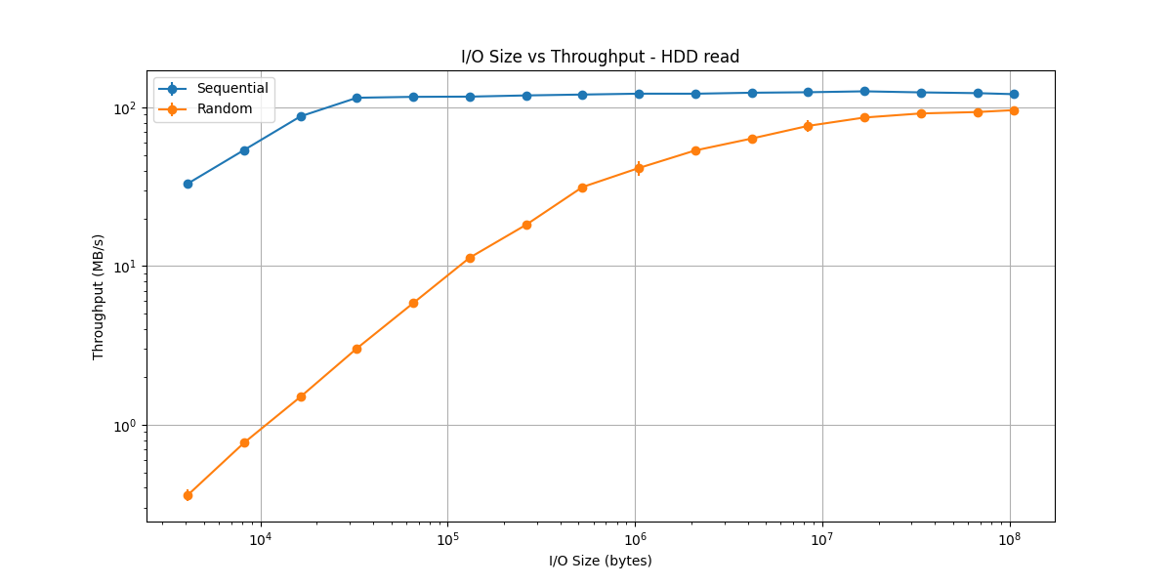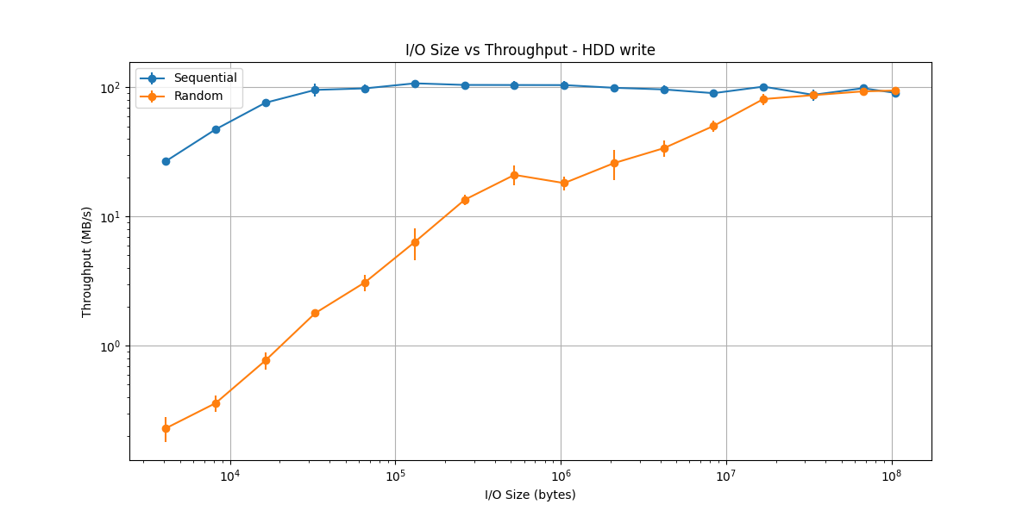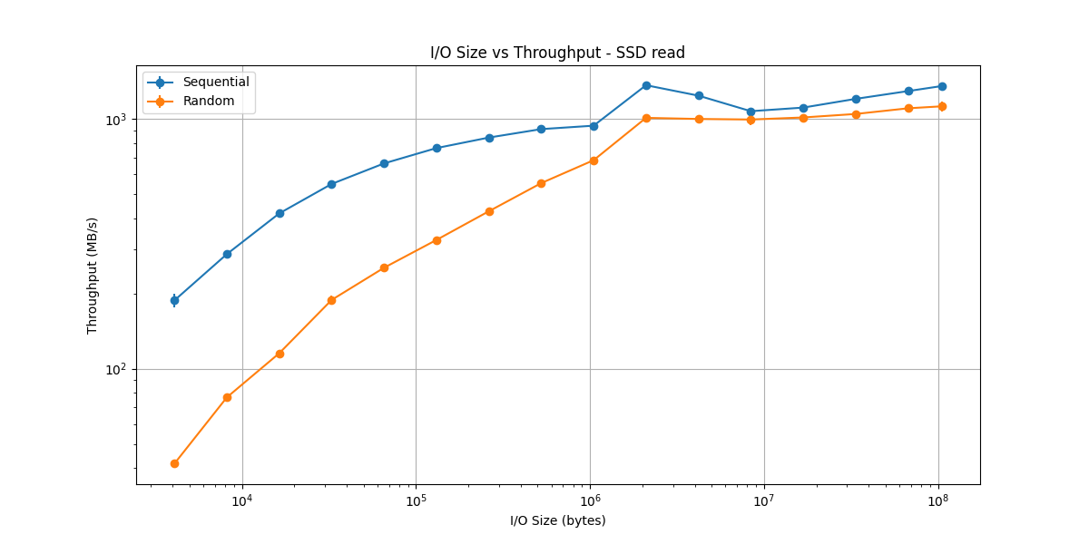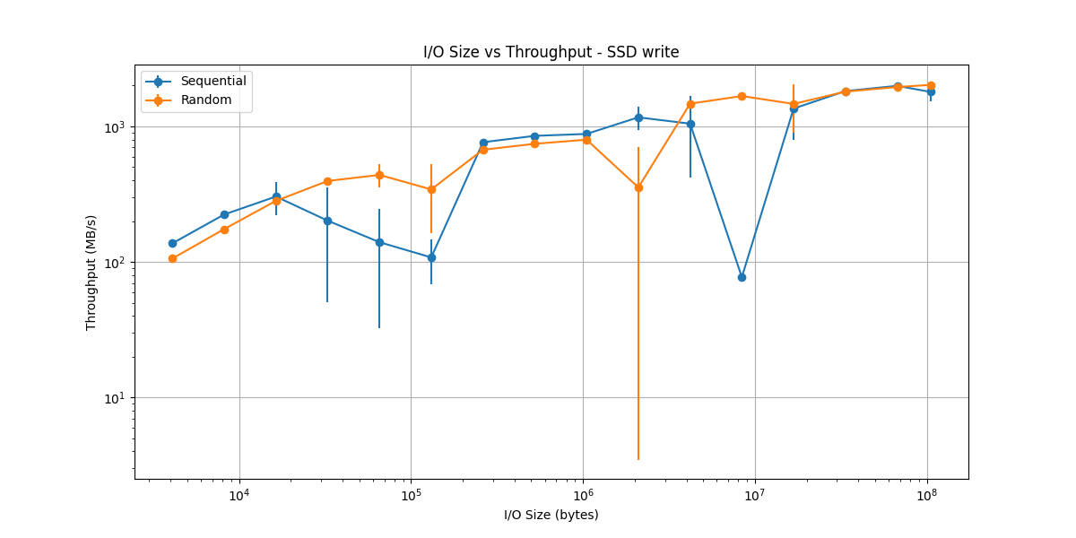  
The I/O size benchmarks demonstrate the expected general trend of increasing throughput with larger I/O sizes, though with significant variance. For both sequential and random operations, we observe that larger I/O sizes typically achieve better throughput by amortizing the overhead of each I/O operation across more data. However, the data shows some unexpected fluctuations, particularly in the SSD write measurements (which we discuss later).

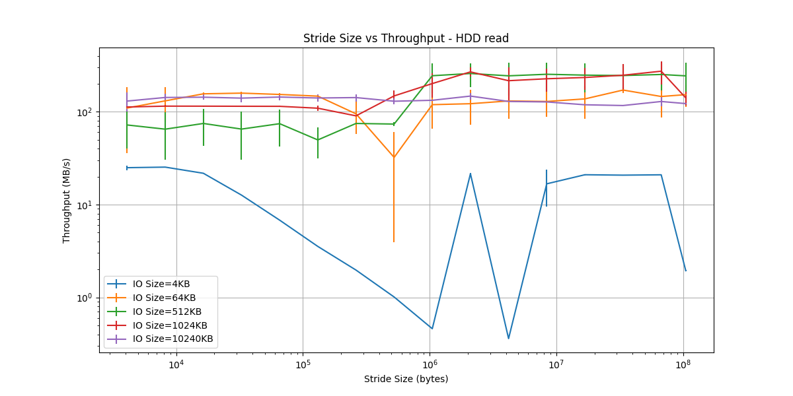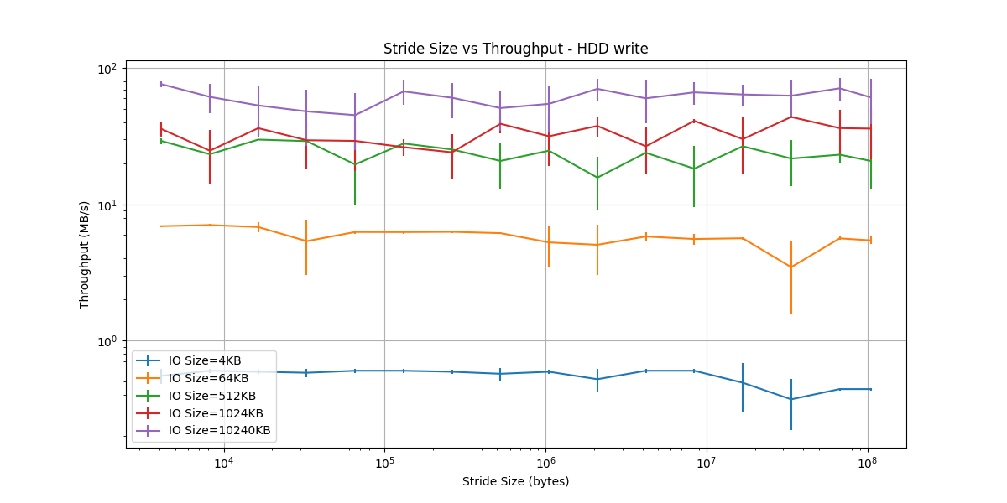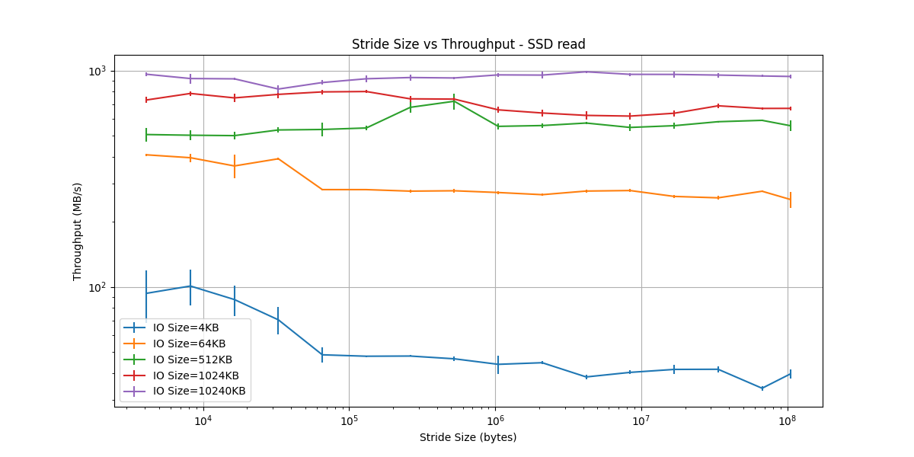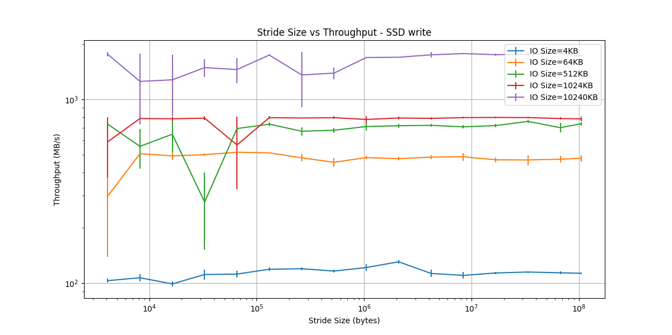  
The stride size measurements show varying patterns of throughput depending on the I/O size used. While we would expect to see relatively consistent performance for the SSD and degrading performance for the HDD as stride size increases, our results show more variance than anticipated.

Sources of Measurement Variance:

The significant variance in our measurements can be attributed to several key factors:

1. Test Environment Configuration:

* The SSD was used as the boot drive, leading to interference from system processes and OS activity
* The HDD was nearly at capacity and not defragmented, forcing the drive head to seek across multiple physical locations on the platters
* File fragmentation likely caused the drive head to move frequently between inner and outer tracks, explaining the observed throughput spikes

1. System-Level Effects:

* Background process interference
* File system buffering decisions
* Disk scheduling algorithm impacts

1. Hardware Considerations:  
   For the HDD specifically, the combination of high capacity utilization and lack of defragmentation created a particularly challenging scenario. When files are fragmented across different physical locations on the platters, the drive head must make longer seeks, leading to:

* Increased seek times between non-contiguous blocks
* More frequent transitions between inner and outer tracks
* Higher variance in throughput measurements
* Occasional spikes in latency during long seeks

These factors make our measurements more representative of real-world conditions where storage devices operate under sub-optimal conditions, rather than idealized benchmark scenarios. The contrast between the SSD's relatively consistent (though still variable) performance and the HDD's highly variable results highlights the fundamental differences between solid-state and rotating storage technologies.

Future benchmarking efforts would benefit from:

* Using a dedicated drive for testing
* Defragmenting the HDD before testing
* Controlling for system load
* Multiple test runs under more controlled conditions

Conclusions and Design Implications

Our experiments yield several key insights for system design and optimization. The data clearly shows that while throughput generally increases with I/O size, it eventually plateaus, suggesting an optimal range rather than a simple "bigger is better" rule. For maximum throughput, large sequential I/O operations are optimal, though the advantage of "random" vs sequential access diminishes at very large I/O sizes, particularly on SSDs.

The impact of stride patterns reveals a fundamental difference between storage technologies. HDDs show significant performance degradation with increased stride sizes due to physical seek times across the platter, while SSDs maintain more consistent performance. This suggests that applications should, where possible, optimize for sequential access patterns, particularly on HDDs. When designing file systems or I/O-intensive applications, minimizing data fragmentation and maintaining locality of reference becomes crucial for HDD performance.

Our measurements also highlight the asymmetry between read and write operations. Background disk activity had a notably larger impact on write performance, particularly visible in our SSD results where the drive served as the boot volume. This aligns with known characteristics of modern storage systems - SSDs handle concurrent reads more efficiently than writes due to their internal architecture, and HDDs generally find writes more costly than reads. This suggests that systems should prioritize read operations where possible and implement strategies like write coalescing to optimize write performance.

These findings have direct implications for system design: applications should aim to minimize random writes, particularly on HDDs, implement read-ahead buffering for sequential access patterns, and consider storage technology characteristics when designing I/O patterns. For mixed workloads, using SSDs for random-access-heavy operations while reserving HDDs for large sequential operations would optimize overall system performance.

Despite the measurement variations in our data, these core patterns provide valuable guidance for real-world system design and optimization decisions.